Name : Likith Chandra
Roll no: 2620040104 , Branch: ECE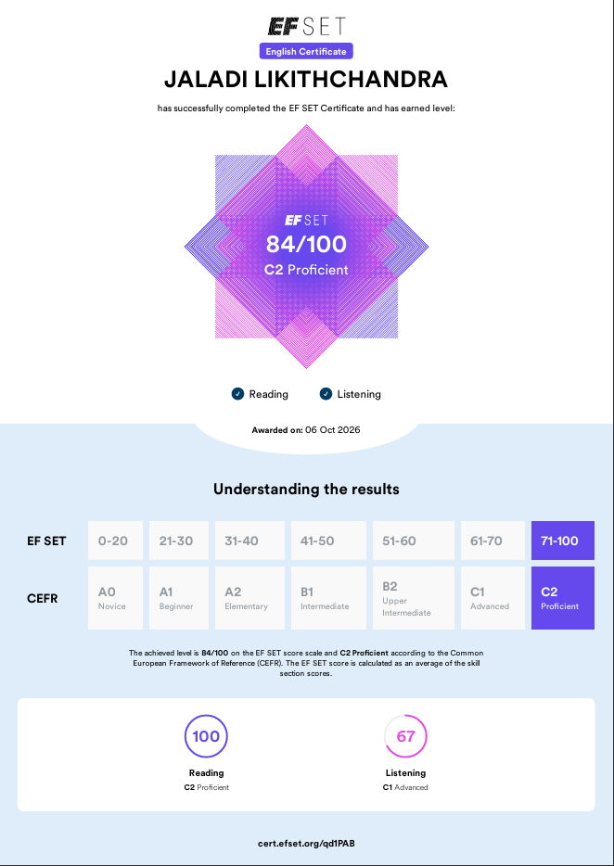
TEAMName:Mahith Chowdary
Roll no: 2620040099, Branch: ECE
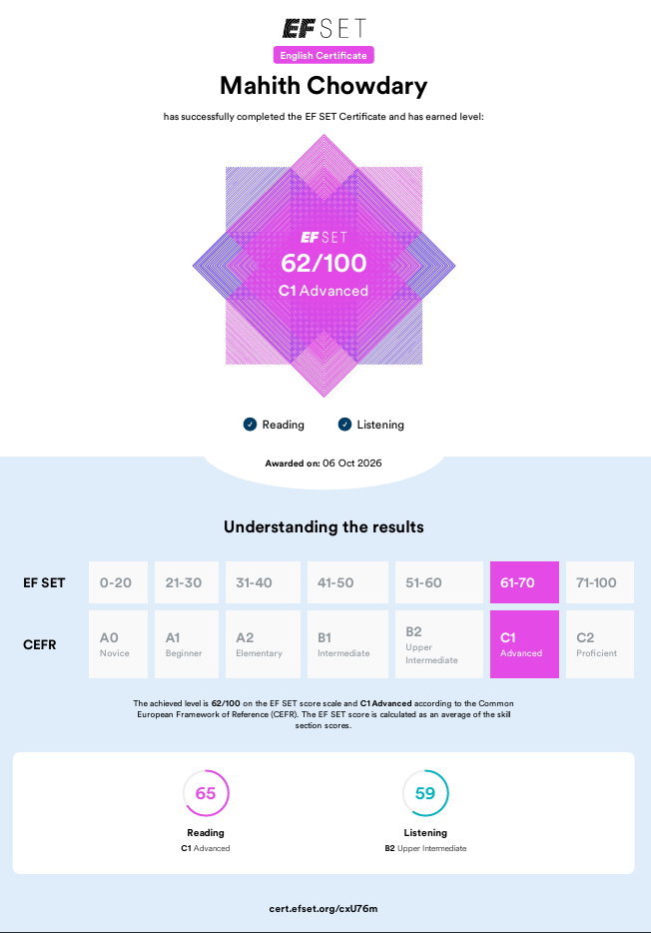
Name: Chandra Harsha
Roll no:2620040082,branch: ECE
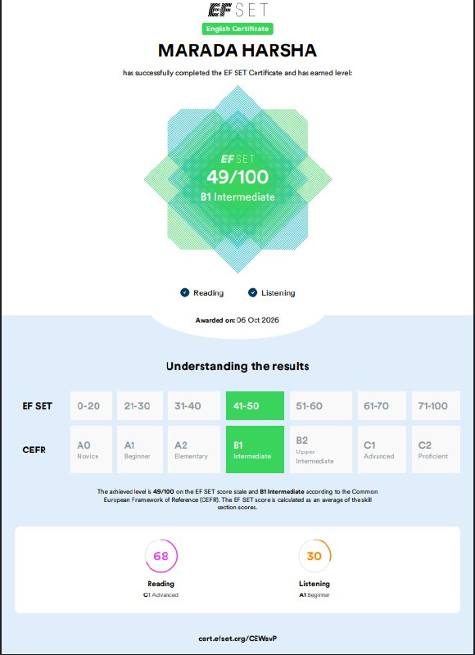

Name : Madala Yatish Chandra
Roll no: 2620040093,Branch : ECE
